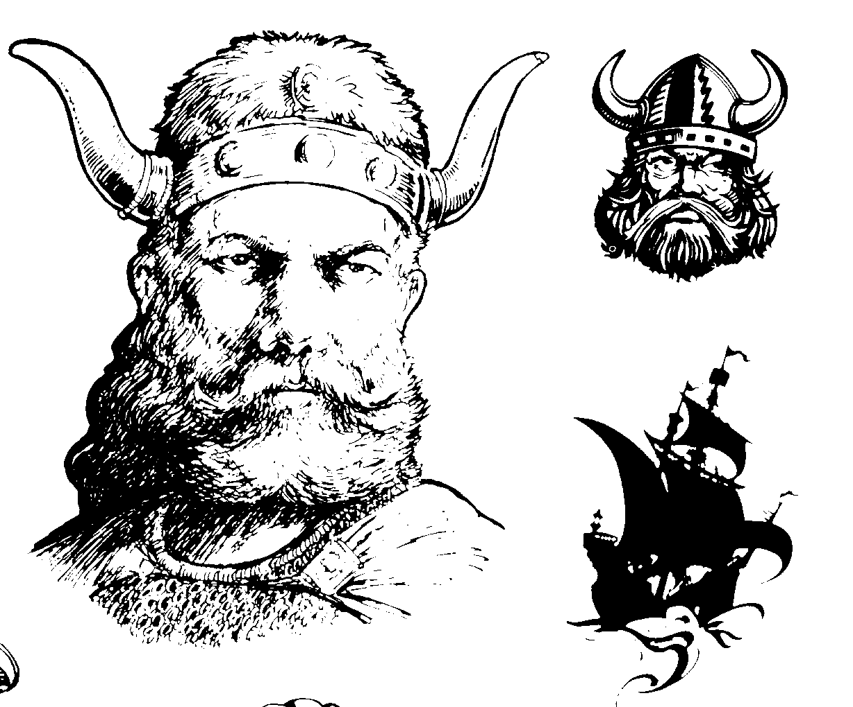

[ III ] Family Tree Branches: Thomas (middle name) Larson

Third Generation Norwegian American
Son of Myrtle Susanna Fortney [II] & Andrew Larsen

Name: Tom Andrew Larson
Born:
Deceased:
Occupation:

Name: wife 2 ?
Occupation:

Married:
Place:

Name: Kerry
B/Plc: .
D/Plc:
Occupation:
S/C: Elizabeth

Name: wife 3 ?
Occupation:

Name: wife 1
Born:
Deceased:
Occupation:



[ III ] Family Tree Branches: Mary (middle name) Larson Langford

Third Generation Norwegian American
Daughter of Myrtle Susanna Fortney [II] & Andrew Larsen

Name: Mary
Born:
Deceased:
Occupation:

Name: John Langford
Born:
Deceased:
Occupation:

Married:
Place:

Name: Lynn Jones
B/Plc: .
D/Plc:
Occupation:
S/C:

Name: Laura Langford Waleen
B/Plc: .
D/Plc:
Occupation:
S/C:

Name: Jonda Martin
B/Plc: .
D/Plc:
Occupation:
S/C:



As I said, Orland has his pix and chart in. Soonest Please!!!

[ III ] Family Tree Branches: Linda (middle name) Larson Olson

Third Generation Norwegian American
Daughter of Myrtle Susanna Fortney [II] & Andrew Larsen

Name: Linda
Born:
Deceased:
Occupation:

Name: Richard Olson
Born:
Deceased:
Occupation:

Married:
Place:

Name:
B/Plc: .
D/Plc:
Occupation:
S/C:

Name:
B/Plc: .
D/Plc:
Occupation:
S/C:

Name:
B/Plc: .
D/Plc:
Occupation:
S/C:

Name:
B/Plc: .
D/Plc:
Occupation:
S/C:

[ III ] Family Tree Branches: Laurel (middle name) Larson

Third Generation Norwegian American
Daughter of Myrtle Susanna Fortney [II] & Andrew Larsen

Name: Laurel
Born:
Deceased:
Occupation:

Name: Ollie Madsen
Born:
Deceased:
Occupation:

Married:
Place:

Name: Josh
B/Plc: .
D/Plc:
Occupation:
S/C:

Name: Jed
B/Plc: .
D/Plc:
Occupation:
S/C:

Name: Jesse
B/Plc: .
D/Plc:
Occupation:
S/C:

Name: Luke
B/Plc: .
D/Plc:
Occupation:
S/C:

